EXPT NO: 9 | TEXT CLASSIFICATION AND TEXT GENERATION USING TRANSFORMERS
DATE: 29.10.2026 | TEXT CLASSIFICATION AND TEXT GENERATION USING TRANSFORMERS

PRE-LAB QUESTIONS (PROVIDE BRIEF ANSWERS TO THE FOLLOWING QUESTIONS)

- What is a Transformer model in Natural Language Processing (NLP)?
A Transformer is a neural network architecture that uses attention mechanisms to understand relationships between words in text.

- What is BERT, and how is it used for text classification?
BERT stands for Bidirectional Encoder Representations from Transformers. It understands the context of words and can be fine-tuned for tasks such as sentiment classification.

- What is fine-tuning in the context of pretrained language models?
Fine-tuning is the process of training a pretrained model on a specific dataset to perform a particular task.

- What is the difference between text classification and text generation?

Text Classification | Text Generation
Assigns a label or category to input text. | Generates new text based on the input.
Predicts predefined classes. | Produces words, sentences, or paragraphs.
Mainly used for text understanding. | Mainly used for text creation.
Example: Positive or negative sentiment prediction. | Example: Generating a summary of a paragraph.
Model example: BERT. | Model example: T5.

- What is a sequence-to-sequence model, and how is it used in text generation?
A sequence-to-sequence model converts an input sequence into an output sequence. It is used in applications such as text summarization, translation, and question answering.
AIM
To implement text classification by fine-tuning a pretrained BERT model and develop a simple sequence-to-sequence text generation application using Transformer models.

SOFTWARE REQUIREMENTS
- Python
- Google Colab
- Hugging Face Transformers
- Hugging Face Datasets
- PyTorch
- NumPy
- Pandas
- Matplotlib

OBJECTIVES
Students will be able to:
- Understand the architecture and working of Transformer models in NLP.
- Understand the concepts of text classification and text generation.
- Load and preprocess text datasets for NLP applications.
- Fine-tune a pretrained BERT model for text classification.
- Evaluate the classification model using appropriate performance metrics.
- Implement a sequence-to-sequence application using a pretrained Transformer model.
- Generate text using the model's text generation capabilities.
- Analyze and compare the outputs produced by the Transformer models.

PROCEDURE
PART A: DATASET PREPARATION AND TEXT PREPROCESSING
Perform the following tasks:
- Load a text dataset such as the IMDb movie review dataset.
- Explore the dataset and examine sample text entries and their labels.
- Check the number of samples and the distribution of class labels.
- Separate the dataset into training and testing sets or use the predefined splits.
- Load a pretrained tokenizer corresponding to the BERT model.
- Tokenize the text using the tokenizer.
- Apply padding and truncation to maintain consistent input lengths.
- Convert the tokenized data into the required format for model training.
- Prepare the dataset for batch-wise processing.

CODE:
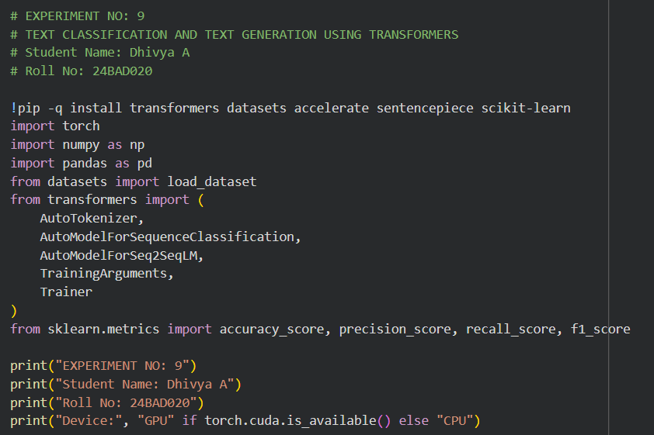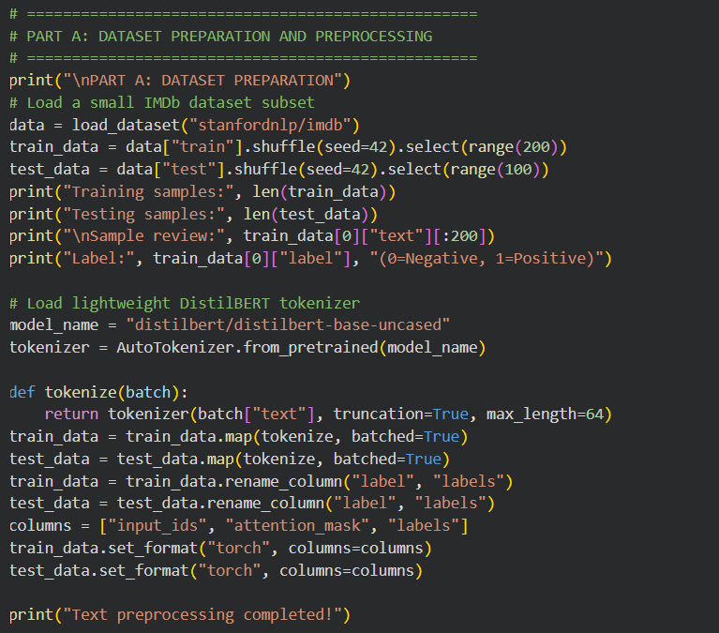

OUTPUT:
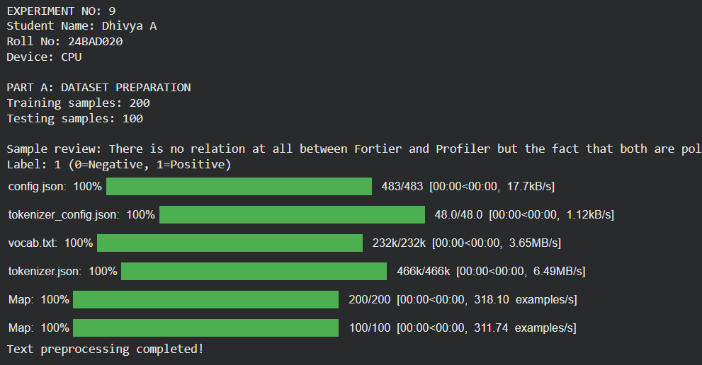

PART B: FINE-TUNING BERT FOR TEXT CLASSIFICATION
Perform the following tasks:
- Load a pretrained BERT model for sequence classification.
- Configure the model for the required number of classes.
- Prepare the tokenized training and testing datasets.
- Define the training parameters, including learning rate, batch size, and number of epochs.
- Fine-tune the BERT model using the training dataset.
- Evaluate the trained model using the testing dataset.
- Calculate appropriate performance metrics, such as accuracy, precision, recall, and F1-score.
- Test the model using new text inputs.
- Display the predicted class labels and corresponding evaluation results.
- Save the fine-tuned model and tokenizer.

CODE:
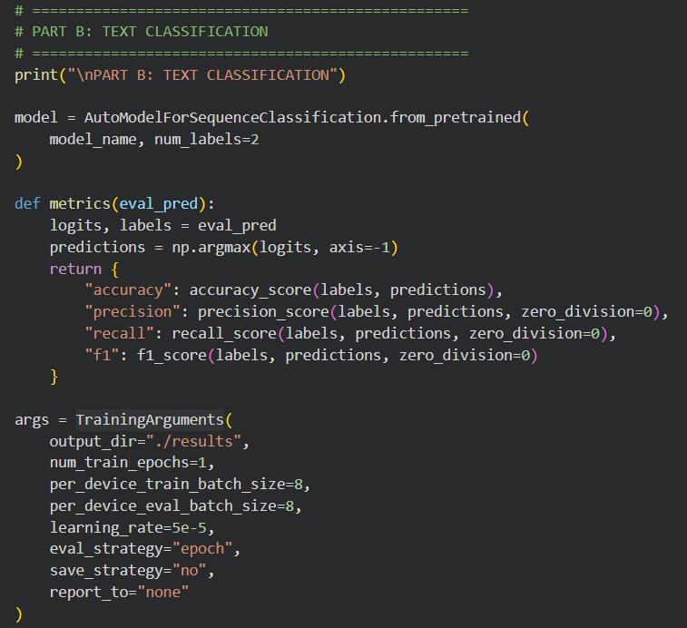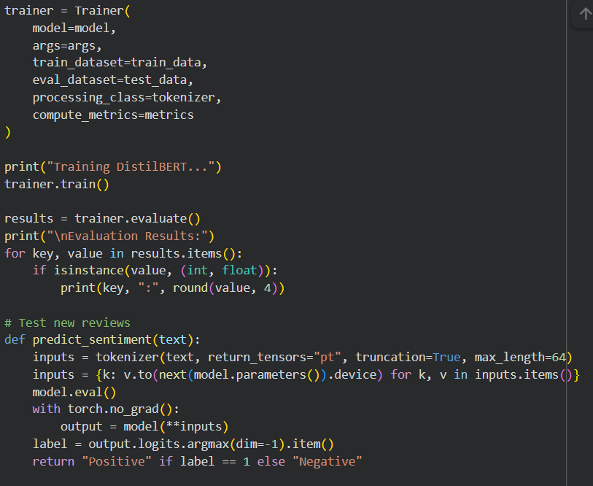
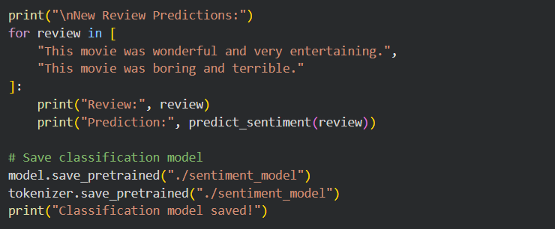
OUTPUT:
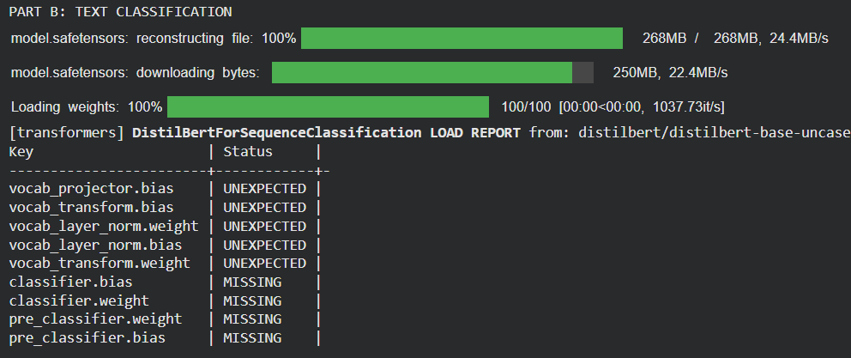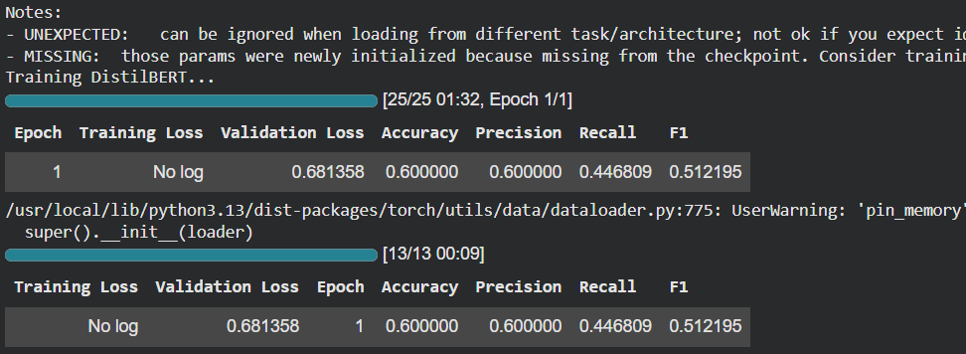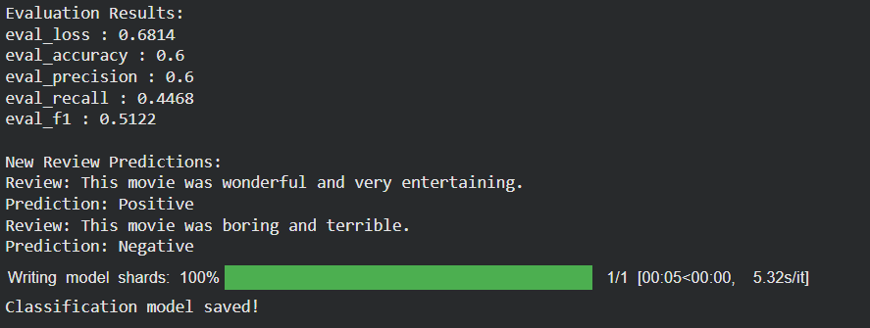

PART C: IMPLEMENTING A SEQUENCE-TO-SEQUENCE APPLICATION USING TRANSFORMERS
Perform the following tasks:
- Load a pretrained sequence-to-sequence Transformer model, such as T5-small.
- Load the corresponding tokenizer.
- Prepare a sample text input for the selected text generation task.
- Preprocess the input according to the model's requirements.
- Generate output text using the pretrained model.
- Apply appropriate generation parameters, such as maximum output length and beam search, where applicable.
- Display the input text and the generated output.
- Experiment with different input texts and generation settings.
- Observe how changes in the input and generation parameters affect the output.
- Save the generated outputs for further analysis.

CODE:
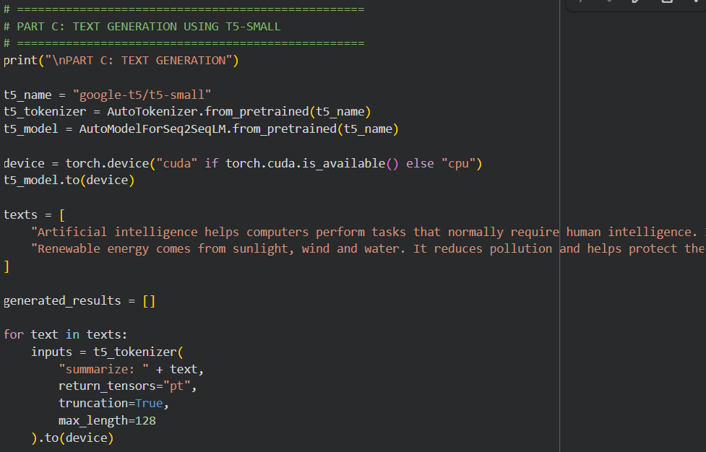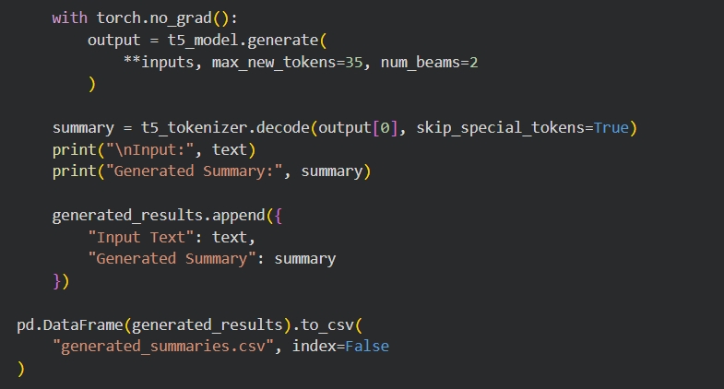

OUTPUT:
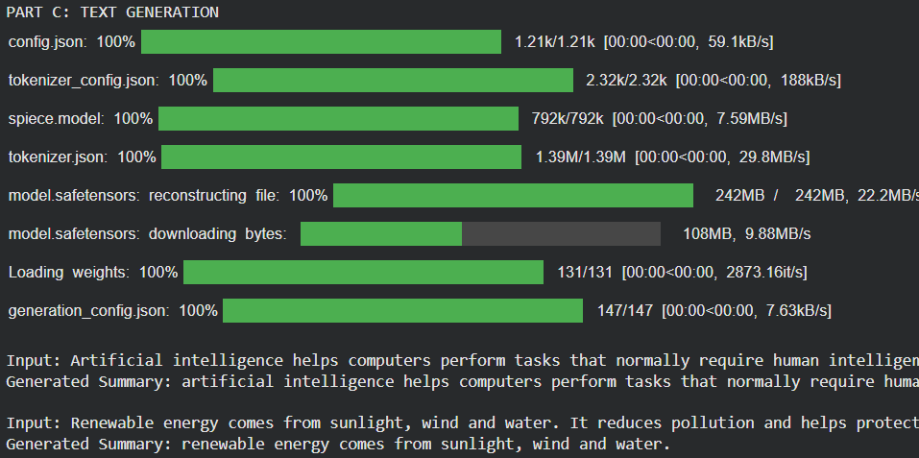

PART D: MODEL TESTING AND OUTPUT ANALYSIS
Perform the following tasks:
- Test the fine-tuned BERT model using sample positive and negative text inputs.
- Record the predicted class labels for the test inputs.
- Analyze the classification results using the selected evaluation metrics.
- Test the sequence-to-sequence model using different input texts.
- Compare the generated outputs for different inputs and generation settings.
- Examine the relevance, readability, and coherence of the generated text.
- Identify possible errors or limitations in the classification and generation outputs.
- Compare the applications of BERT-based classification and sequence-to-sequence text generation.
- Summarize the observations obtained from both models.

CODE:
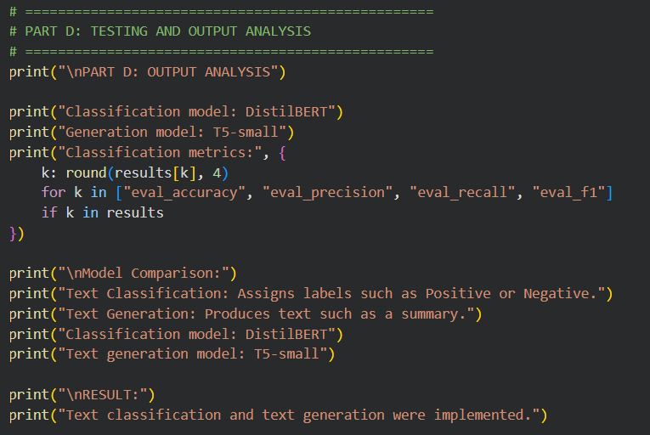

OUTPUT:
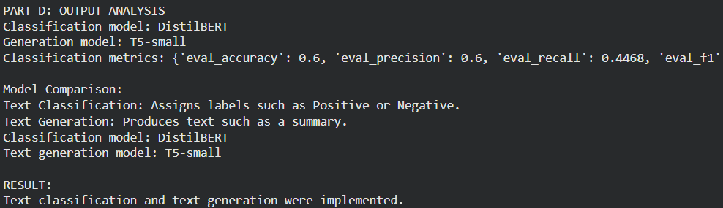

EXPECTED OUTCOME
Students will understand the architecture and applications of Transformer models in Natural Language Processing. They will learn to fine-tune a pretrained BERT model for text classification, preprocess textual data, and evaluate classification performance using appropriate metrics. Students will also develop a simple sequence-to-sequence text generation application using a pretrained Transformer model and analyze the quality and relevance of the generated outputs.

POST-LAB QUESTIONS (PROVIDE BRIEF ANSWERS TO THE FOLLOWING QUESTIONS)

- What is the role of BERT in text classification?
BERT understands the contextual meaning of words and uses this information to classify text into predefined categories.

- Why is tokenization required before providing text to a Transformer model?
Tokenization converts text into tokens and numerical IDs that can be processed by the Transformer model.

- What is the purpose of fine-tuning a pretrained BERT model?
Fine-tuning adapts the pretrained BERT model to a specific task, such as classifying movie reviews into positive and negative categories.

- Mention any two-evaluation metrics used for text classification.
Accuracy
F1-score

- What is the role of the encoder and decoder in a sequence-to-sequence Transformer?
The encoder processes the input sequence and extracts its information. The decoder uses this information to generate the output sequence.

- What is the difference between text classification and text generation?
Text classification predicts a category or label for the input text, whereas text generation creates new text based on the input.

- How does the maximum output length affect text generation?
Maximum output length limits the number of tokens generated by the model. A higher limit allows longer outputs, while a lower limit produces shorter outputs.

- Mention one real-world application of Transformer-based text classification and one application of text generation.
Text classification: Spam email detection.
Text generation: Automatic text summarization.

SUGGESTIONS FOR DATASETS & MODELS
Datasets:
- IMDb Movie Reviews – https://huggingface.co/datasets/stanfordnlp/imdb
- GLUE Benchmark – https://huggingface.co/datasets/nyu-mll/glue
- SST-2 Sentiment Classification – https://huggingface.co/datasets/nyu-mll/glue

Pretrained Models:
- BERT Base Uncased – https://huggingface.co/google-bert/bert-base-uncased
- T5-small – https://huggingface.co/google-t5/t5-small

ASSESSMENT
Description | Max Marks | Marks Awarded
Pre Lab Exercise | 5
In Lab Exercise | 10
Post Lab Exercise | 5
Viva | 10
Total | 30
Faculty Signature

